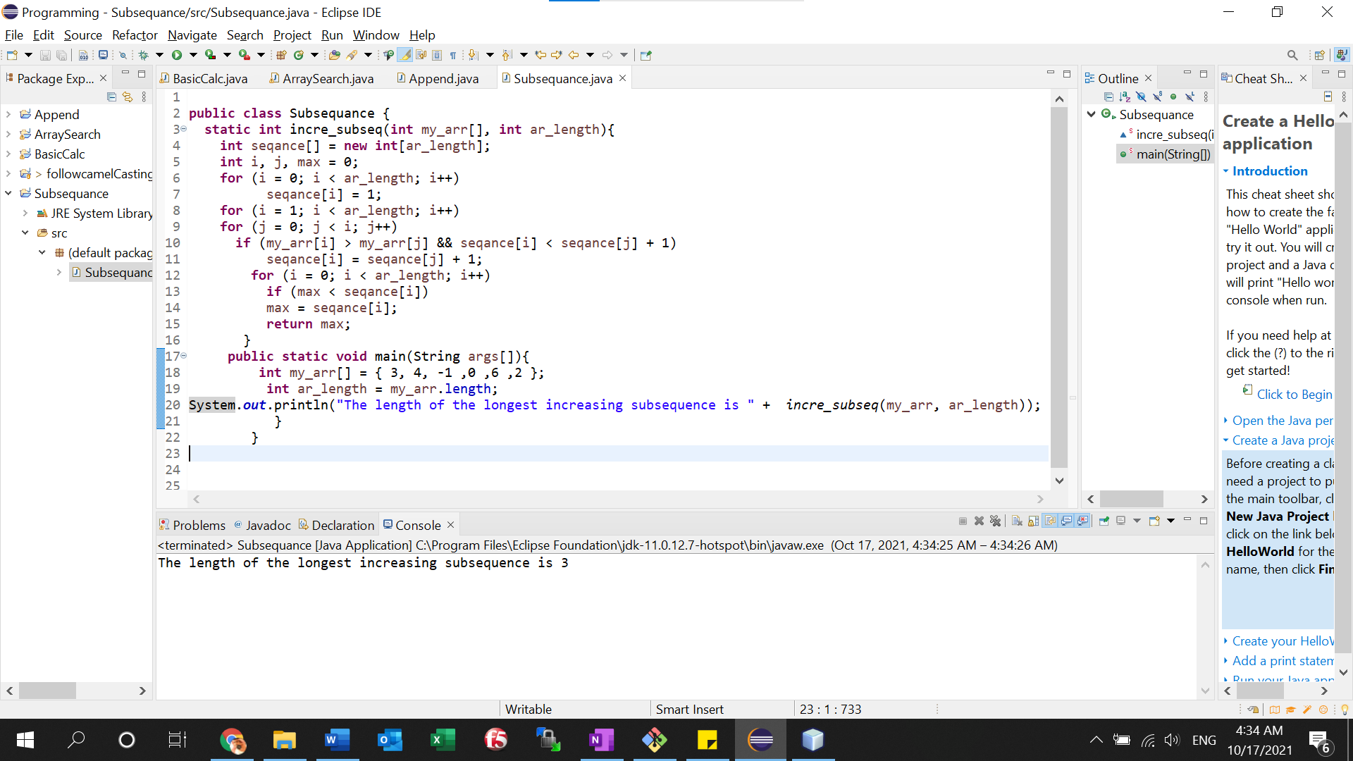

Another values:

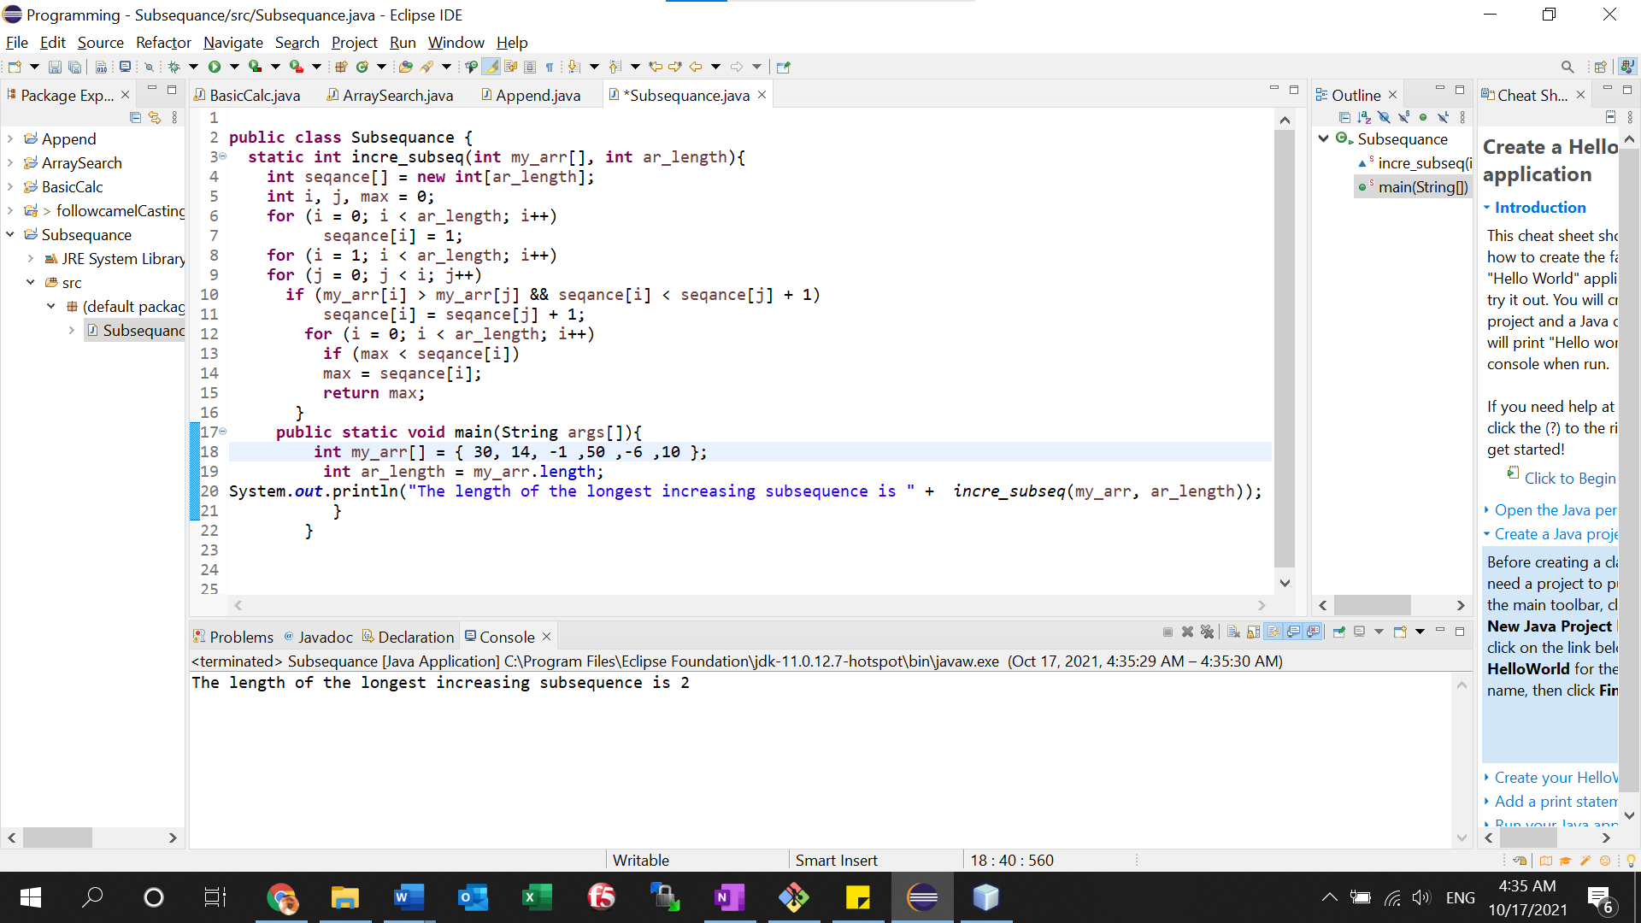

Source code:

**public** **class** Subsequance {

**static** **int** incre_subseq(**int** my_arr[], **int** ar_length){

**int** seqance[] = **new** **int**[ar_length];

**int** i, j, max = 0;

**for** (i = 0; i < ar_length; i++)

seqance[i] = 1;

**for** (i = 1; i < ar_length; i++)

**for** (j = 0; j < i; j++)

**if** (my_arr[i] > my_arr[j] && seqance[i] < seqance[j] + 1)

seqance[i] = seqance[j] + 1;

**for** (i = 0; i < ar_length; i++)

**if** (max < seqance[i])

max = seqance[i];

**return** max;

}

**public** **static** **void** main(String args[]){

**int** my_arr[] = { 30, 14, -1 ,50 ,-6 ,10 };

**int** ar_length = my_arr.length;

System.***out***.println("The length of the longest increasing subsequence is " + *incre_subseq*(my_arr, ar_length));

}

}